Web penetration testing
Task :5,6&7
Password Cracking
SQL injection
OWASP Testing
TASK 5
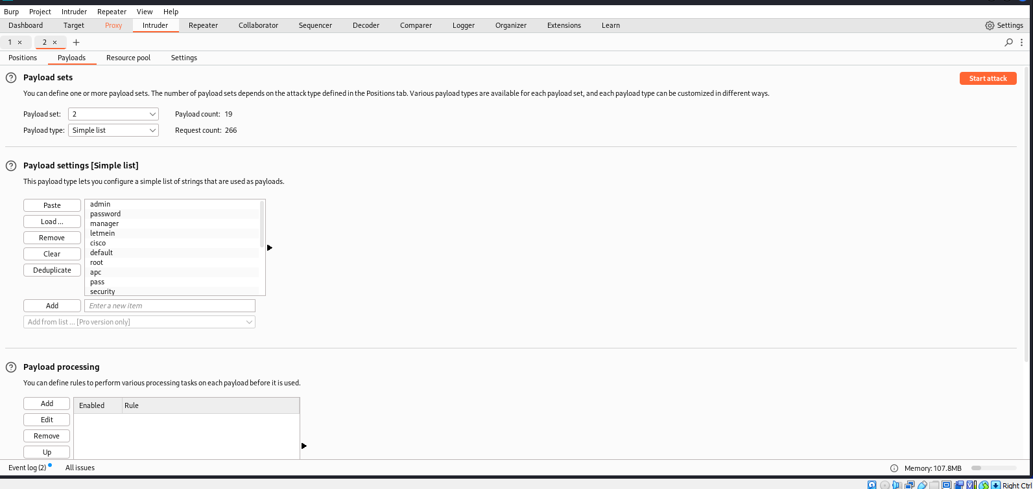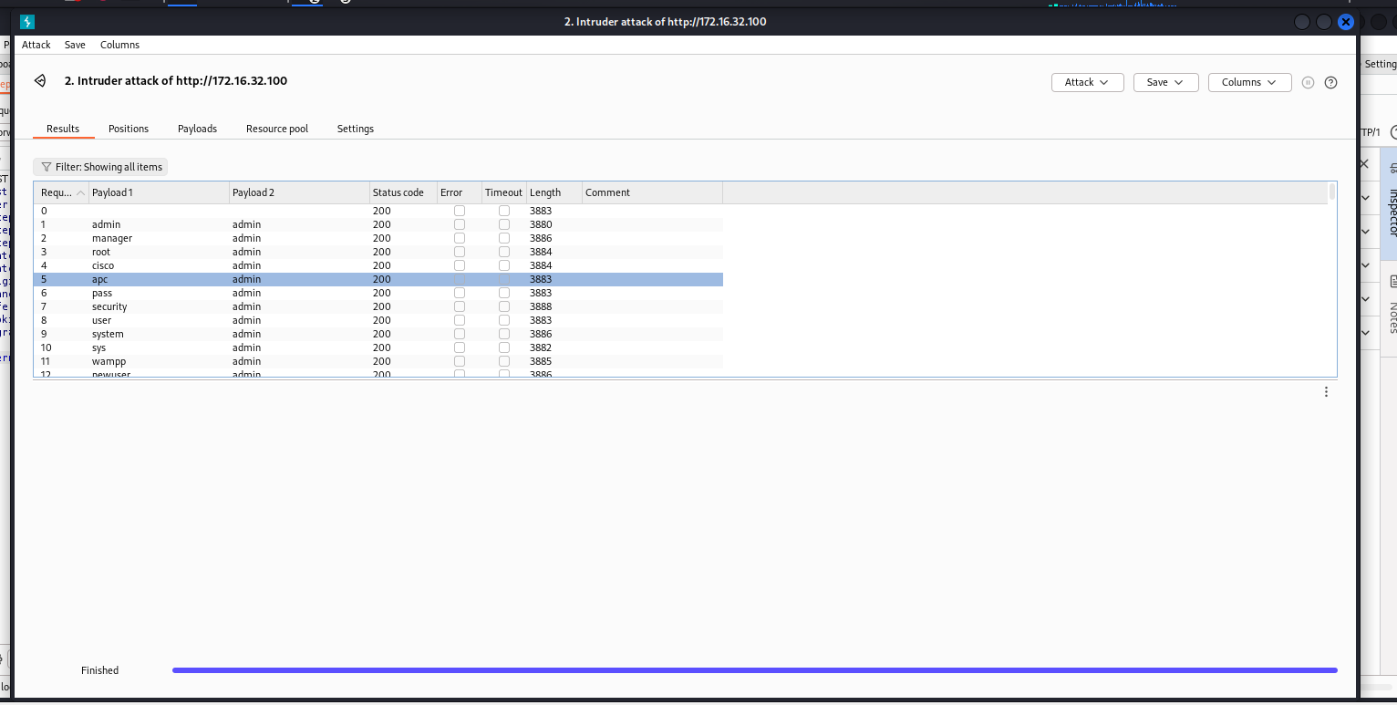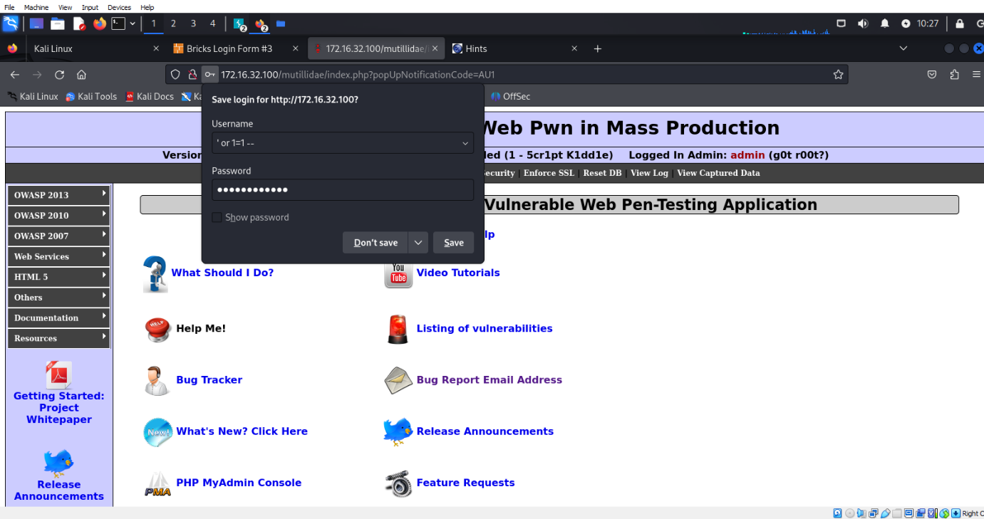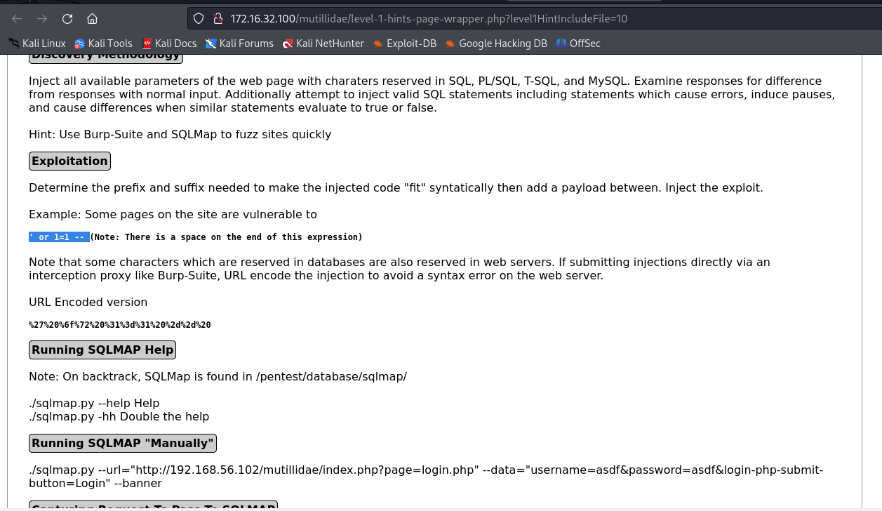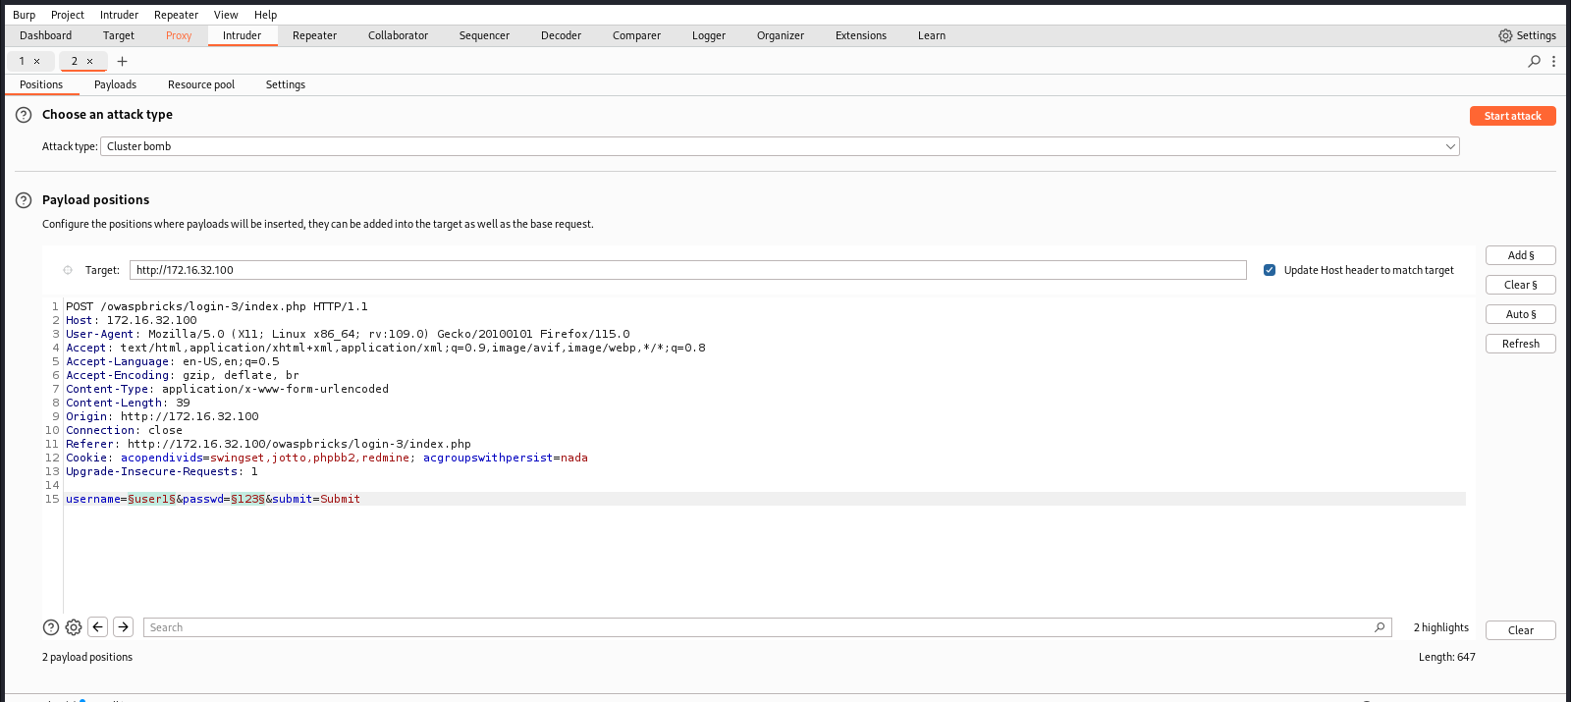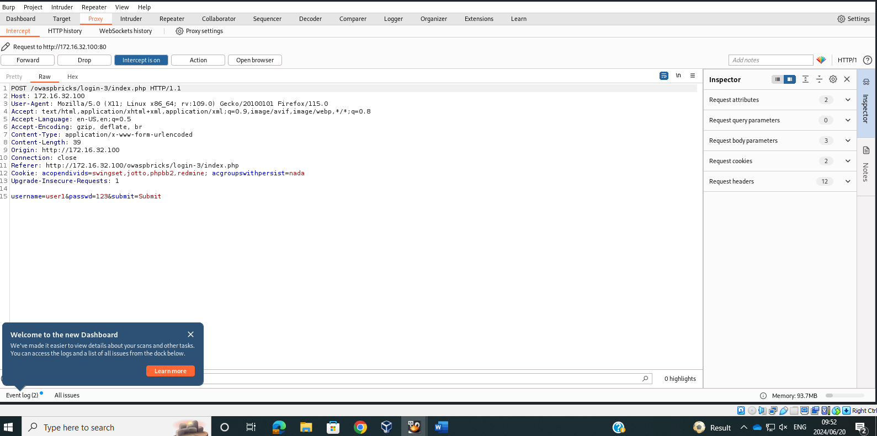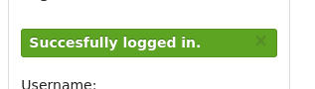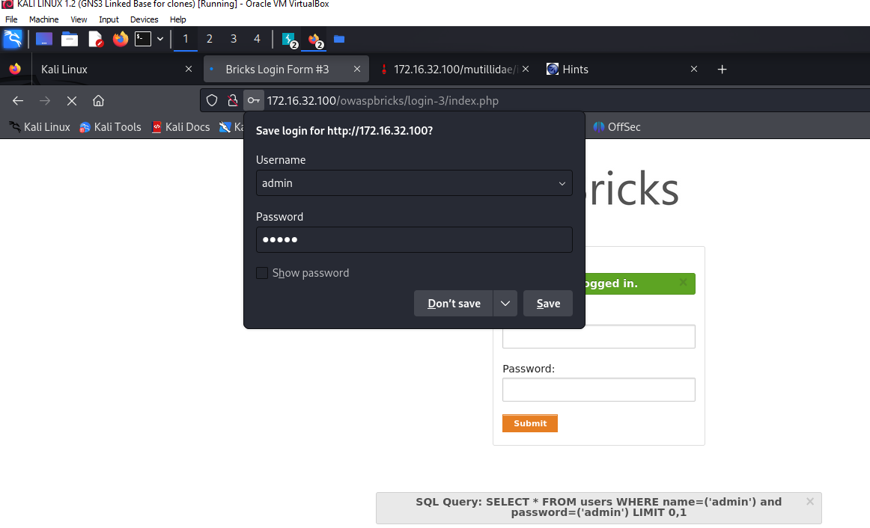
TASK 6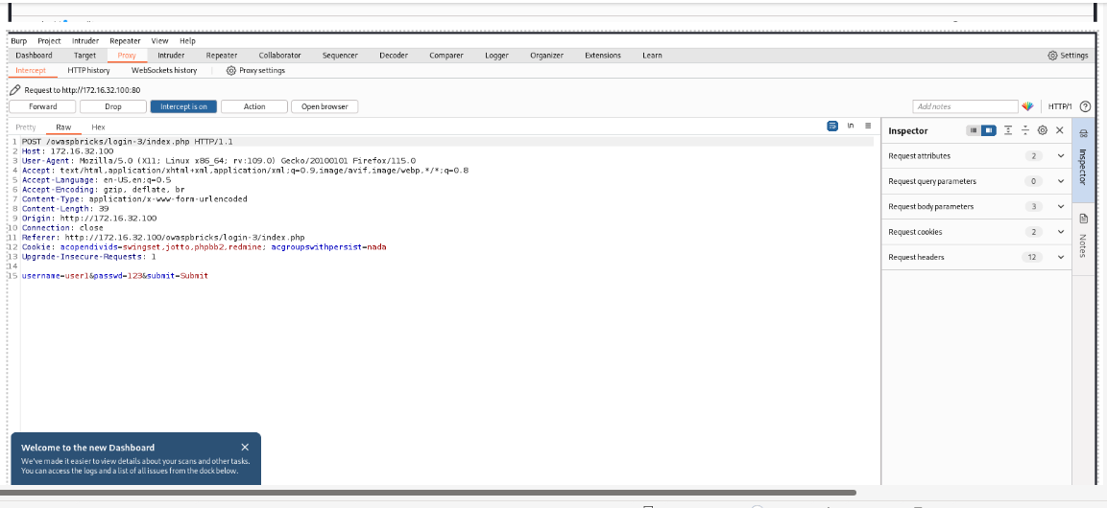

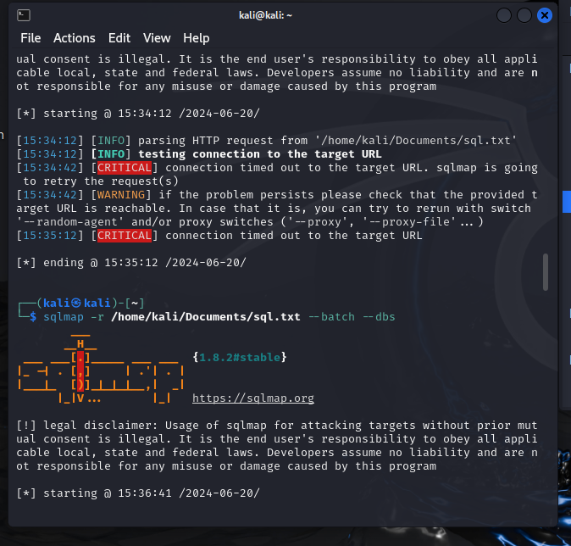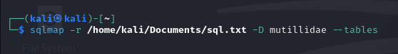

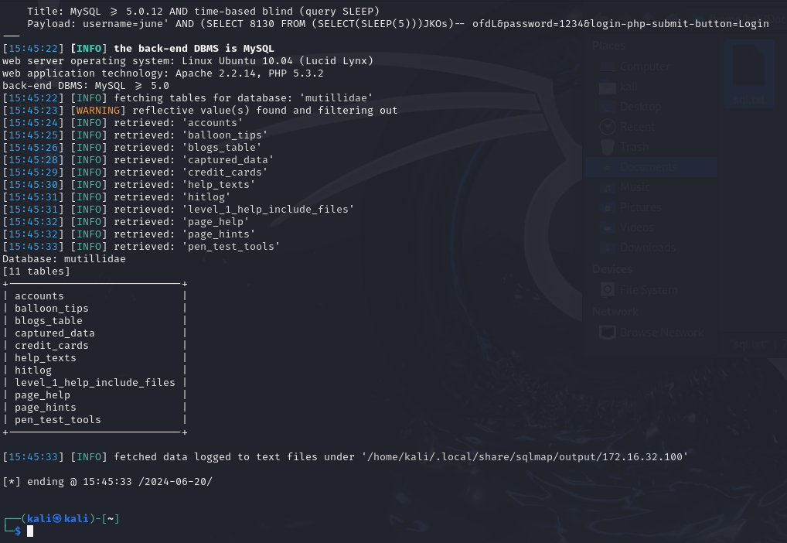
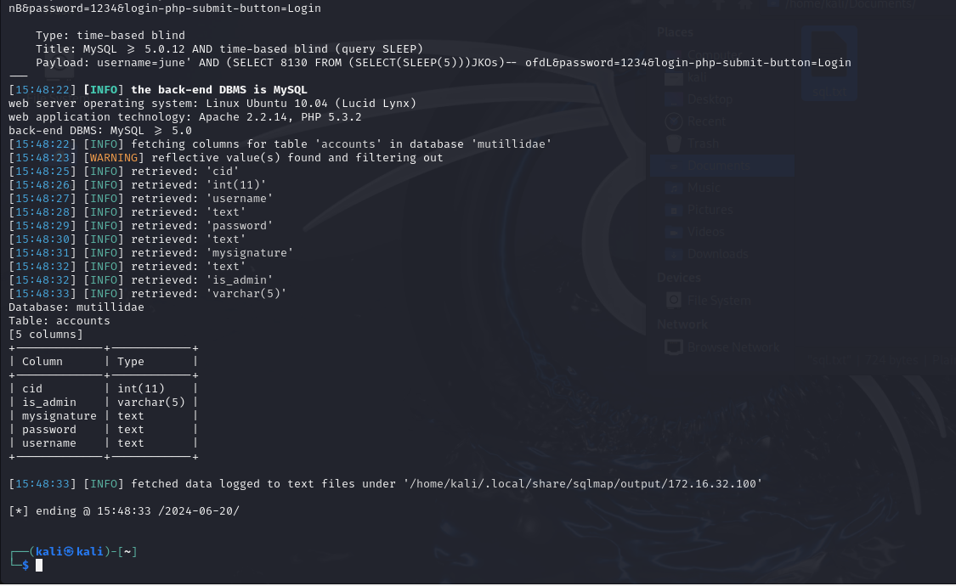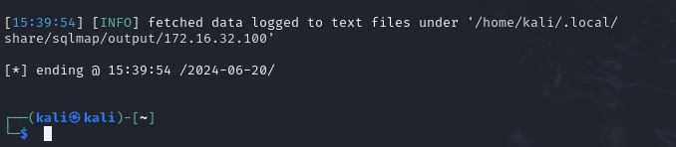
SECTION D
TASK 7
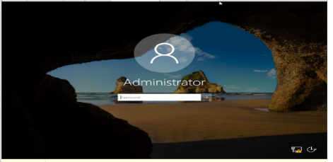
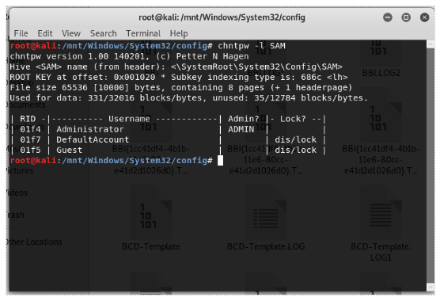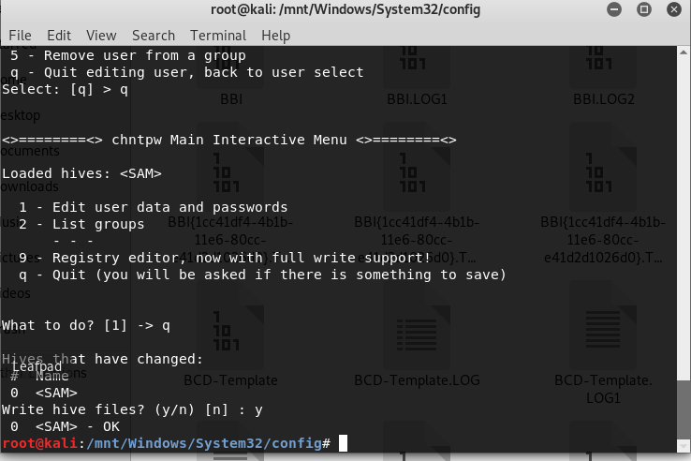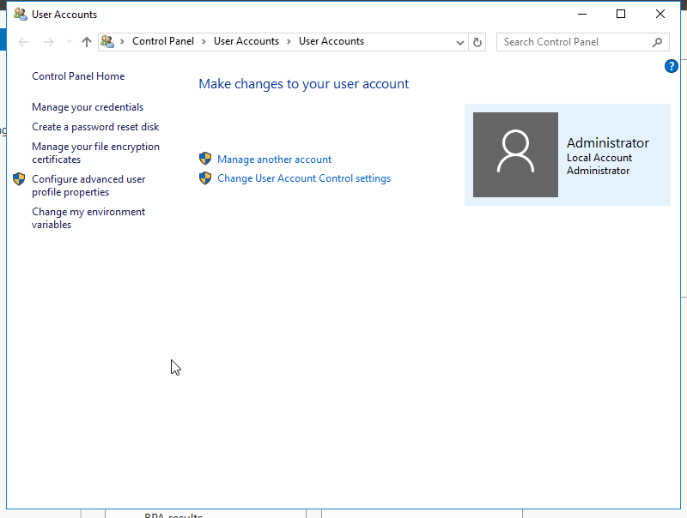
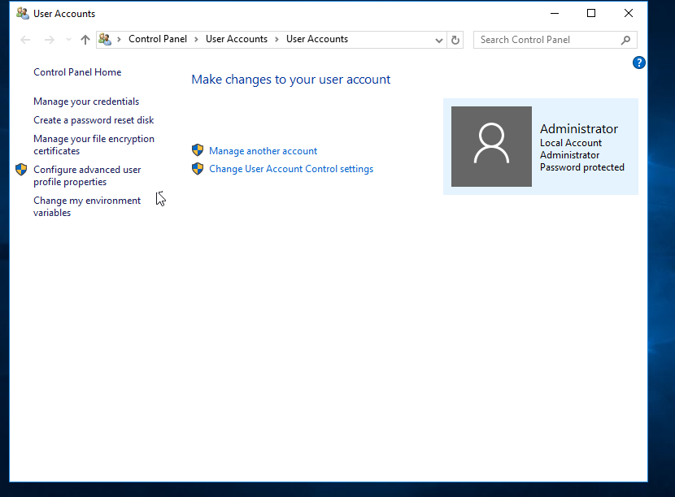
Task 8 :
Reporting
The major goal of this project was to implement and build virtual boxes that would be used to crack passwords and use Kali Linux and Owasp to hack accounts and websites in the future. For this project, there was little study done; it was just you trying to arrange things with what you already knew. Utilizing the Nmap tool along with a few additional commands, I was able to scan the network, identify vulnerabilities, and check for vulnerability scans while also pinpointing several online Apps. For this study, I thus employed password cracking, SQL injection, and other methods to gain access to areas I am not authorized to. I would recommend that the business implement two

